50% reduction in fees for pupils in receipt of Free School Meals
100% reduction in fees for Children in Care
Calculations will be deducted in each period, but the form only needs to sent in once for the year.
APPLICATIONS CAN ONLY BE MADE PER TERM
Email the completed form to music.service@norfolk.gov.uk
If demand exceeds budget, eligible applications will be awarded on a first come first served basis
Norfolk Music Service operates the following remission policy for pupils in receipt of Norfolk Music Service Instrumental Tuition or membership of a Norfolk Music Service led ensemble:
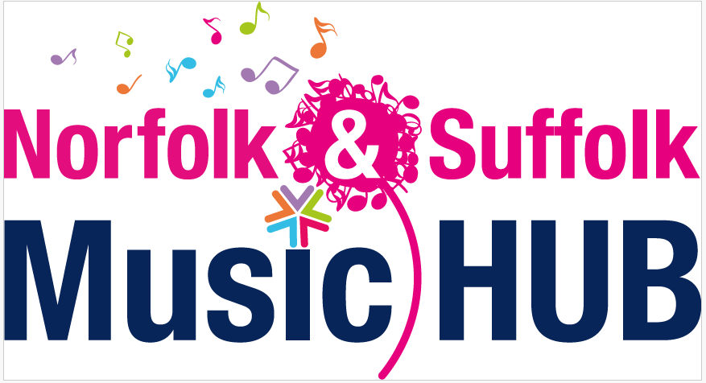

Name of School
Name of Contact
Email address;
Date;
Period of Claim

Pupil First Name | Surname | Year Group | Age | Remission Group; FSM or CIC | No of weeks claimed for | Ensemble Group

